1. **Work package**

The work package, tasks under a work package, are all represented as nodes of a tree. The schedules. Status of the task, milestones and resources are all treated like properties of the node.

At the root is “Project” . Multiple work packages can be created under a project.

The project can only be created by the site administrator. Other users can only create “work package” (if required we can make it “contract package”).Contract package is main monitoring entity.

Tasks can be created under contract package. Each task can have schedule (star/end dates), resources as well as milestones. Optionally documents can also be associated with tasks.

Workpackage (Contract package) is the basic unit of monitoring. Clicking “workpackage” in main menu displays three options shown in screen shot below.

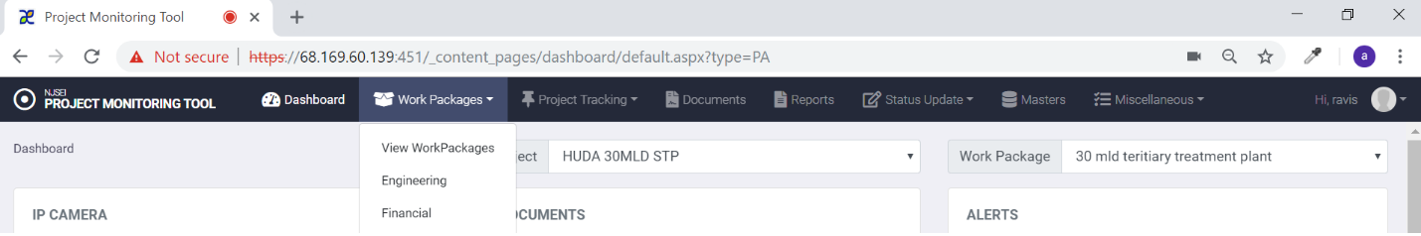

This menu allows user to

* + 1. View work package – See list of work package, create a new work package,
    2. Engineering- View all engineering details of a work package (tasks, sub-tasks-next level sub-tasks…)
    3. Financial- View all financial information related to work package.

This menu has three options as shown below (View work packages ,Engineering and Financial). Each Contract package can be configured as work package**.**



1. Click on “work package”
2. Click on “engineering” in drop down menu.

You will see following screen.

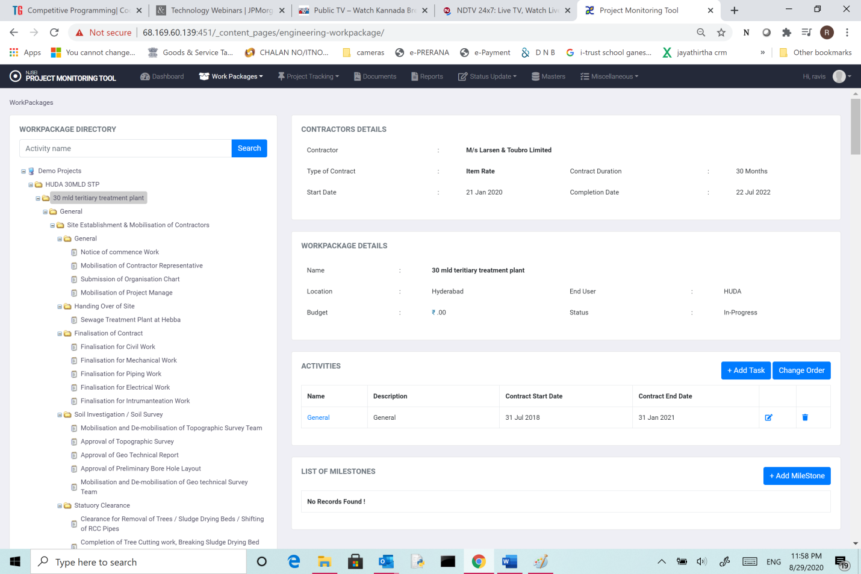

Top of the tree (In the screen shown “Demo Projects”) , is a project-Group.

Under that is projects (in the screen “HUDA 30 MLD stp”)

Under projects is work packages (in the screen “30 mldteritiary treatment plant)

Click on any node on the tree, you will see details on right panel.

Expanding tree nodes:The “+” sign preceding node name shows that the node/task has subtasks. Clicking on “+” will expand the tree below. Same can be used to collapse a tree node

* + 1. **View** **Work package:**

1. Click on “work package “in main menu.
2. Choose “View work package” in drop down.
3. You see following screen.

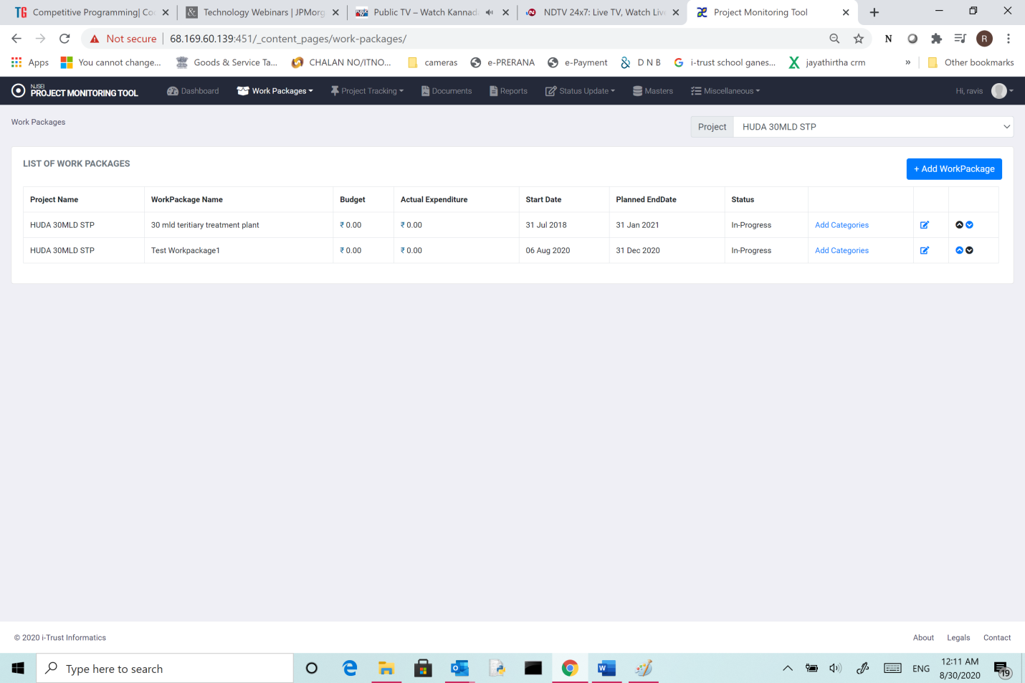

Fig-2

You will see a table showing following details of all work packages.

1. Project Name,.
2. Work package name,
3. Budget,
4. Actual expenditure,
5. Start date
6. Projected end date,
7. Status(current implementation status)
8. Add Categories: This will help you add document categories. Click on “add categories”, you get following screen.

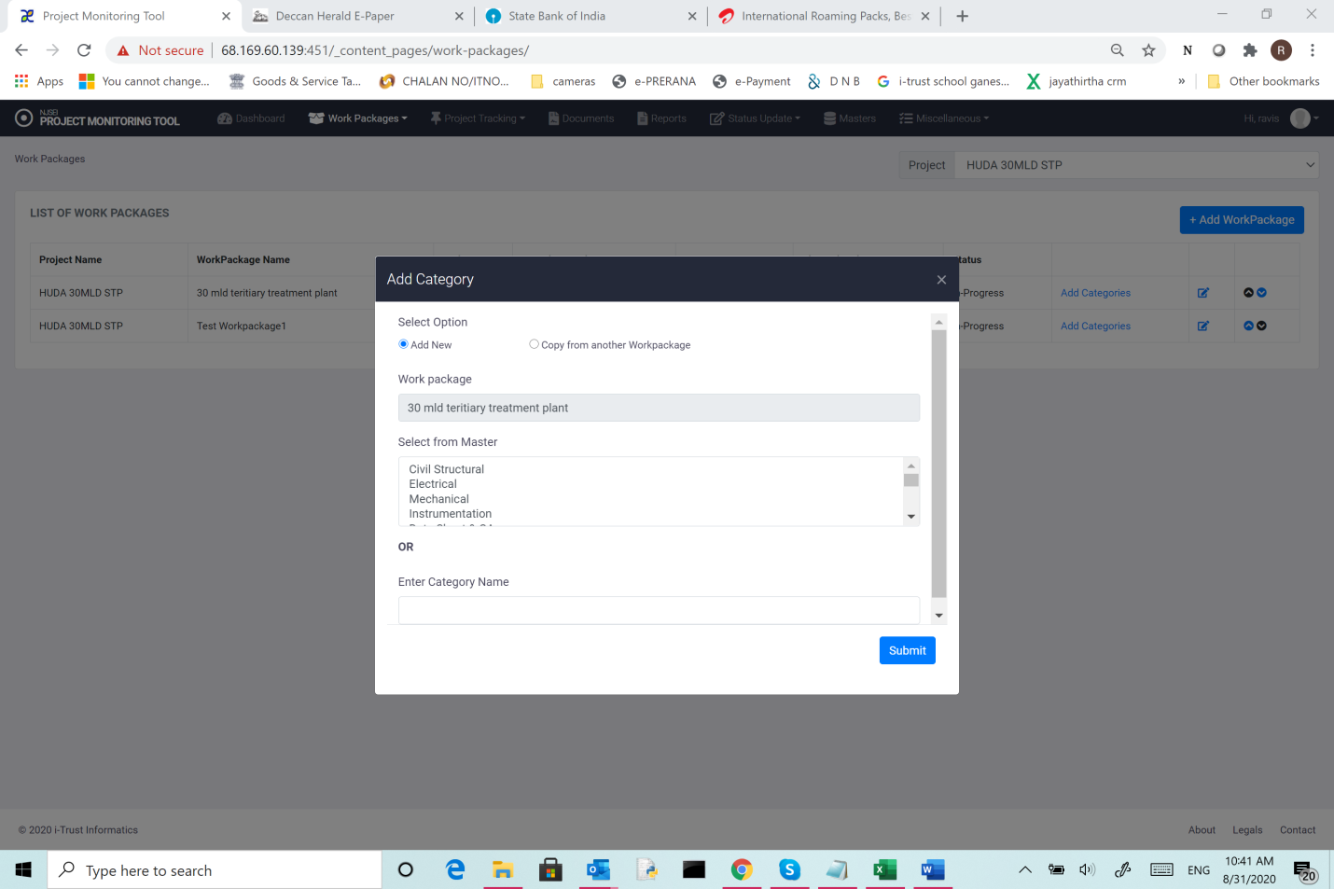

You can add category from existing categories or add new category.

You can also copy complete category tree from another work package using “copy from another work package”

1. “Edit” button will help you change properties of work package.
2. The last two arrows “Up/Down” arrows help you to change the order in which work packages are displayed in the table.
   * 1. **Add work package:**
3. Click on “work package “ in main menu.
4. Choose “View work package” in drop down.

The table shows already configured work packages.

1. Click on “add work package” and see following screen.

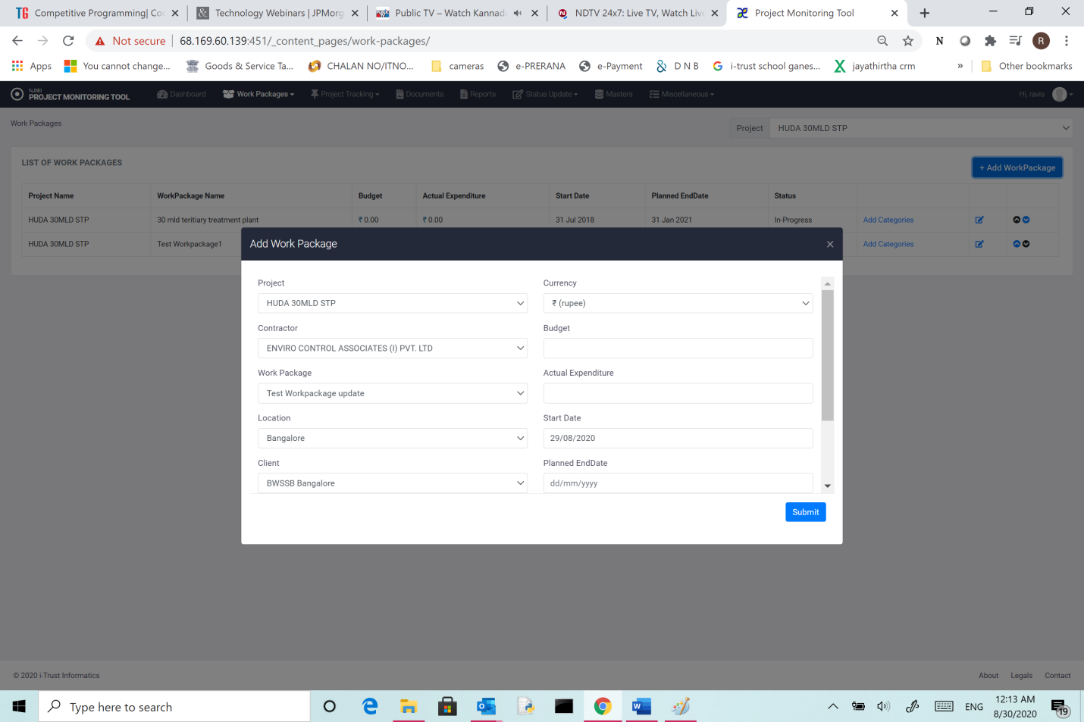

The details to be added for each work package is shown.

Contractor is a drop down list. This is from a master list of contractors.

Work Package name: Name assigned to the contract (Ex:30 mldtertiary treatment plant, Hebbal)

Location: Choose from available list.

Client: Choose from available list.

Budget: Budget (this drop down allows you to choose currency (INR/USD/YEN)

Actual expenditure: Actual expenditure incurred so far

Start date:

Planned end date:

Projected end date: More relevant if work is in progress and there is change in completion date foreseen. Otherwise enter the same value as Planned end date,

Assign user: This option is to assign an administrative user to a work package who has all rights to configure work package. There can be multiple users assigned to same work package. Only after the admin enters the details, if a user signs in, he will see work package.

Status: Current status of work package (not started, in progress, complete)

Click “submit” to complete creation of work package.

* 1. **View Engineering details of workpackages:**

1. Click on “work package “ in main menu.
2. Choose “engineering” in drop down.

You see following screen. Tree view shows all activities and sub-tasks of work package.

1. Click on any activity node ( ex: work package name) .
2. You will see following details.

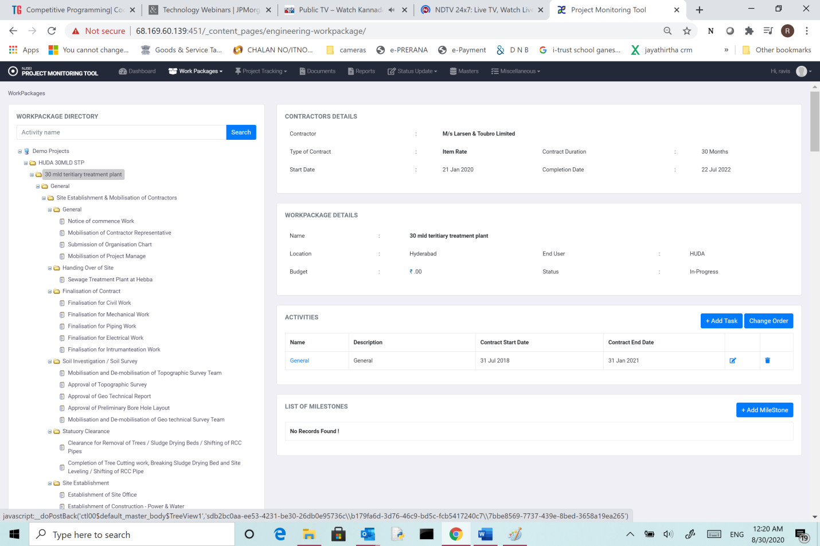

You will see

1. Contractor details -Name of the contractor, type of contract, contract description, start date, completion date.
2. Work package details: Name, location, end user, budget and status.
3. Activities: List of major activities (tasks) under that work package with details like name, description, contract start date, contract end date
4. List of Milestones: Milestones identified for workpackage are shown.
5. Resources: List of resources for workpackageare shown .
   * 1. **Add task:**
6. Click on “work package “ in main menu.
7. Choose “engineering” in drop down.

You see Three view which shows all activities and sub-tasks of work package.

1. Click on Work package node.
2. Click on “add tasks” on the right panel.

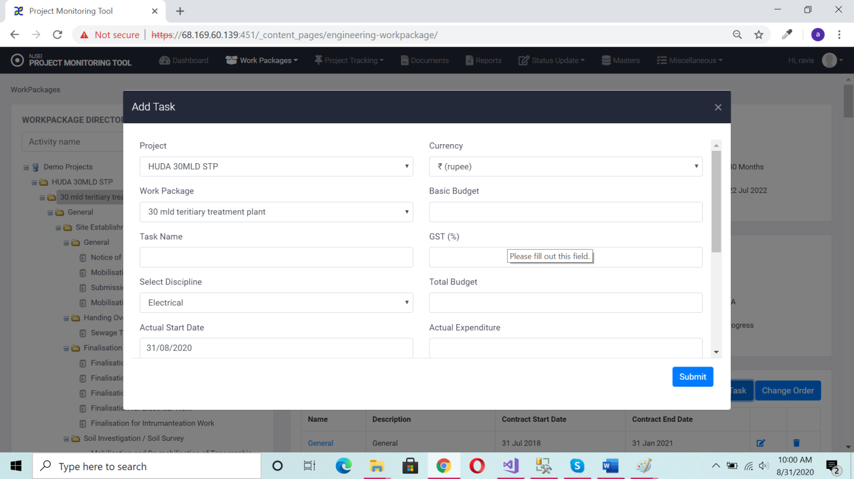

**Task name**: Name assigned to the task

**Discipline**: Choose from available list.

**Actual Start date**:

**Planned end date**: As per submitted plan.

**Projected start date**: (relevant if project has not started on planned date)

**Owner**: Choose from drop down list the user who has ownership rights on activity.

**Description**: Brief description of activity

**Currency**: Choose currency (INR/USD/YEN) for budget.

**Budget**: Budget (in chosen currency- INR/USD/YEN)

**GST** : in Percentage.

**Actual expenditure**: Actual expenditure incurred so far

**Actual end date**:

**Planned end date**: As per submitted plan.

**Projected end date**: (relevant if project has not ended on planned date)

**Status:**Current status of the activity.

**Click “Submit**”

Once saved, the task will be shown as a node in the tree view below the “work package”

Note that you can add sub tasks to a task by choosing the task .

**3.2.2 Add Milestone:**

1. Click on “work package “ in main menu.
2. Choose “engineering” in drop down.
3. You see following screen. Three view shows all activities and sub-tasks of work package.
4. Click on Work package node.
5. Click on “add milestones” on the right panel.

For each task, there can be milestones. By choosing “Add milestones” you see following screen.

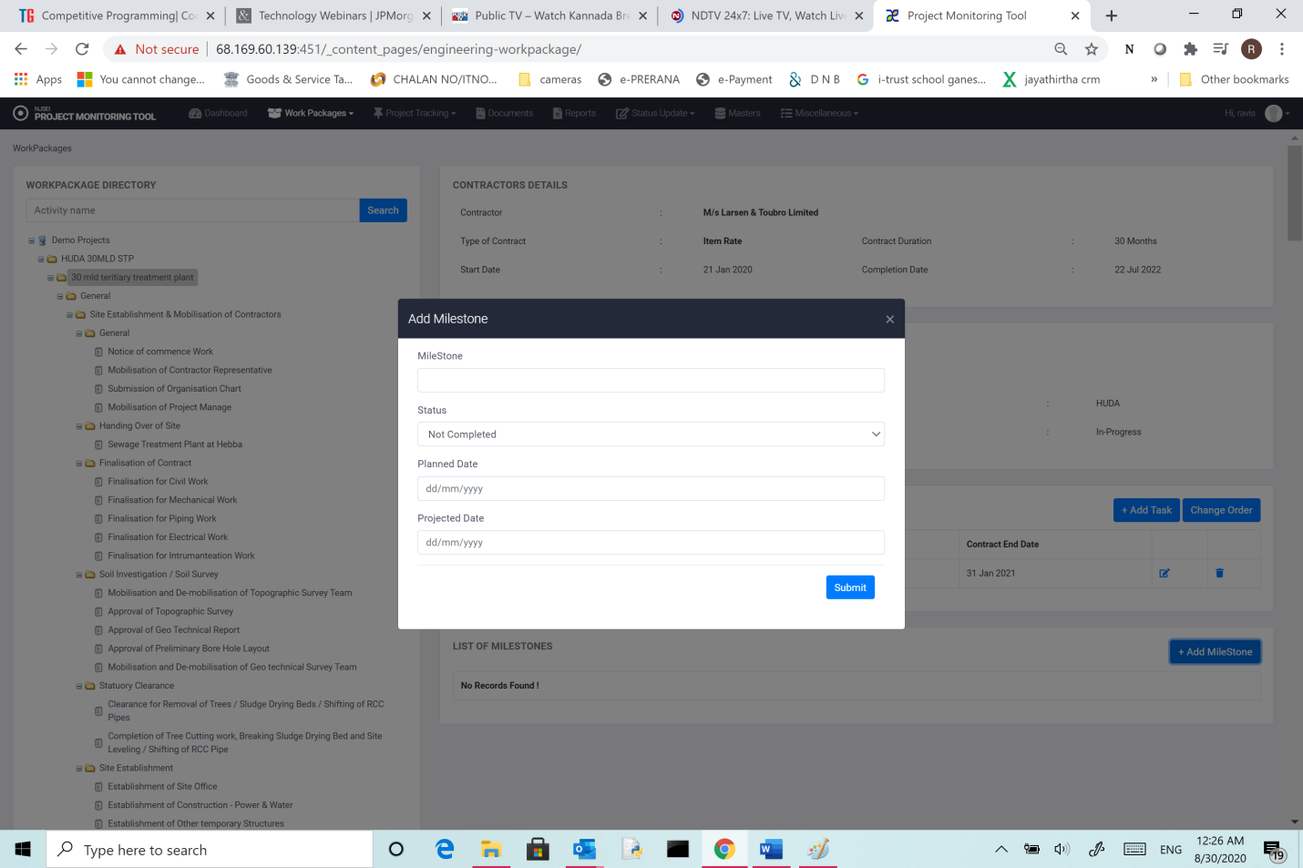

Add following detailsof the milestone

1. Name of the milestone,
2. Status (choose from drop down list of options)
3. Planned date
4. Projected date (initial planned date is same as projected date)
5. Click “submit”
   * 1. **Add Resource:**
6. Click on “work package “in main menu.
7. Choose “engineering” in drop down.
8. You see following screen.
9. Three view shows all activities and sub-tasks of work package.
10. Click on Work package node.
11. Click on “add resource” on the right panel.

Then you get following screen.

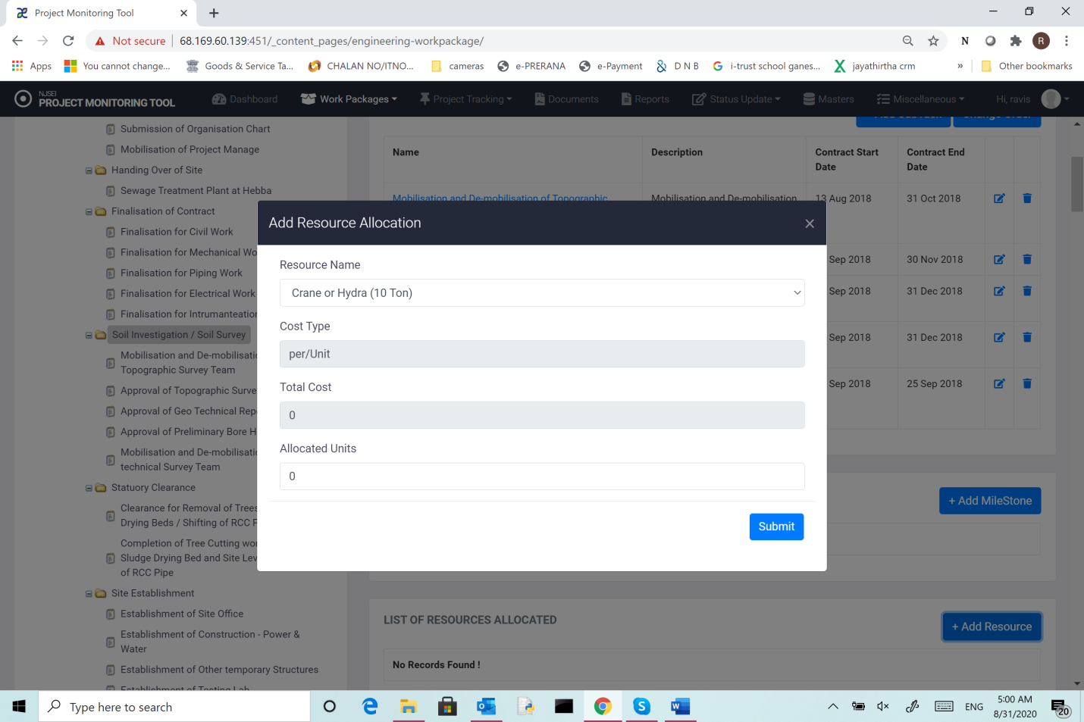

Add following information about resources.

1. The resource name is selection from master resource list.**(**The master can be updated by site administrator which is explained separately).
2. Cost type (choose appropriate cost type).
3. Total cost: Enter total cost of resource of this type that is allocated to the task.
4. Allocated units: enter number of units of resource allocated to the task.
5. Click “submit”
   * 1. **Change Order:**

This will help you change the order in which the activities at same level are displayed in the tree view.

1. Click on “work package “in main menu.
2. Choose “engineering” in drop down.
3. You see following screen.
4. Three view shows all activities and sub-tasks of work package.
5. Click on Work package node.
6. Click on “Change order” on the right panel.

You will see following screen.

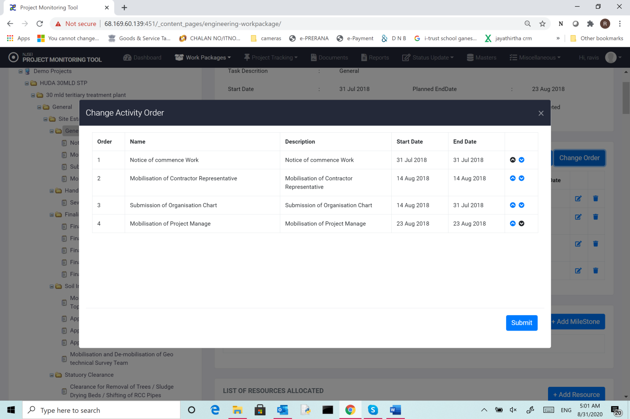

You can use “Up/Down” arrows to change the order and press “submit” button.

* 1. **View Financial details of workpackages:**

This shows the financial information of various taks/sub-tasks of work package. The tasks/sub-tasks for this need not necessarily be same as for engineering tasks (Example: you may monitor financial information at higher level than engineering information).

* 1. Click on “work package “ in main menu.
  2. Choose “financial” in drop down.
  3. You see following screen. Tree view shows all activities and sub-tasks of work package.

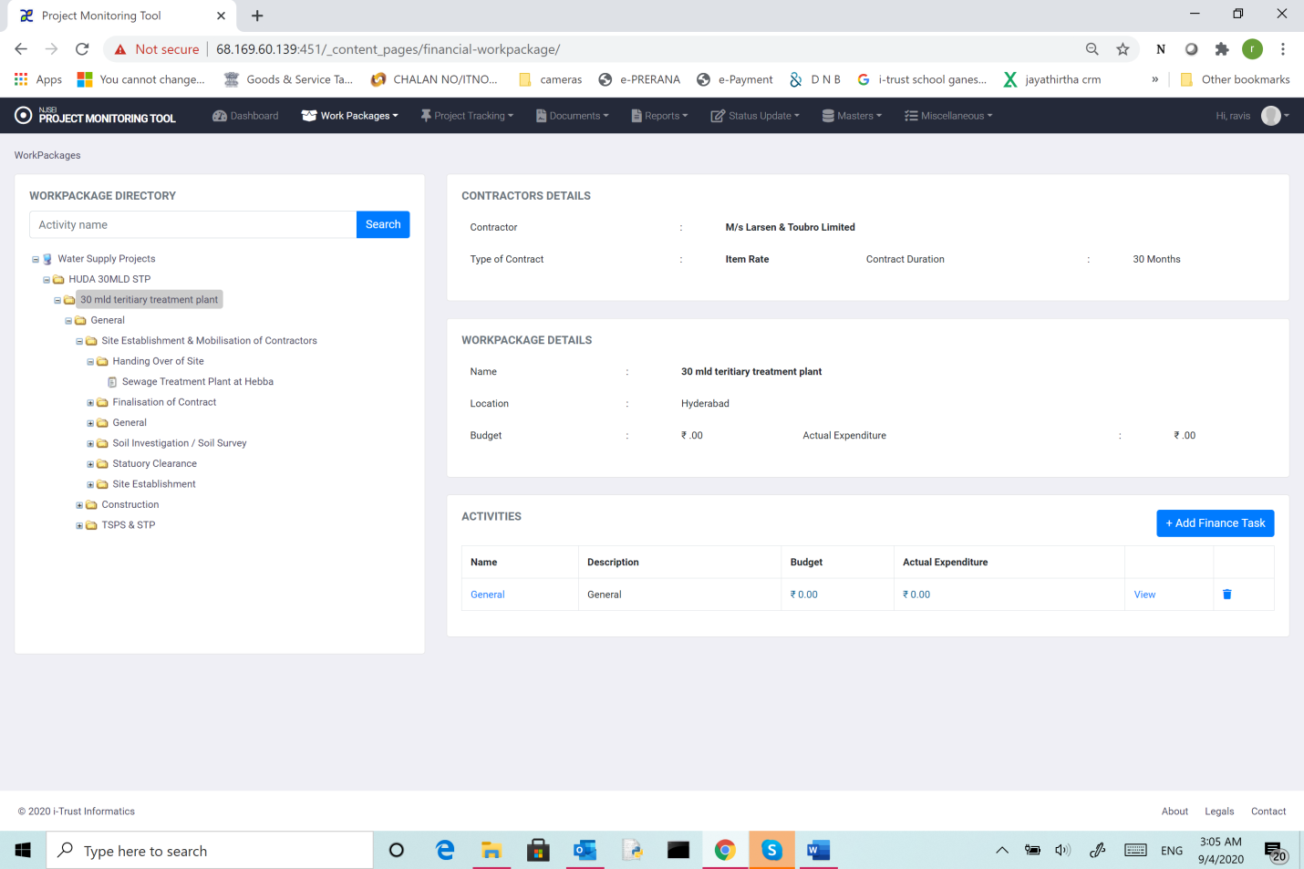

Click on any activity node ( ex: work package name) .

You will see following details.

1. Contractor details -Name of the contractor, type of contract, contract description, start date, completion date.
2. Work package details: Name, location, end user, budget and status.
3. Activities: List of major activities (tasks) under that work package with details like name, description, contract start date, contract end date

**3.3.2 Add financial tasks of workpackages:**

1. Click on “work package “ in main menu.
2. Choose “Financial” in drop down.

You see Tree view which shows all activities and sub-tasks (Financial) of work package.

1. Click on Work package node.
2. Click on “Add Financial Tasks” on the right panel.

You will see following screen.

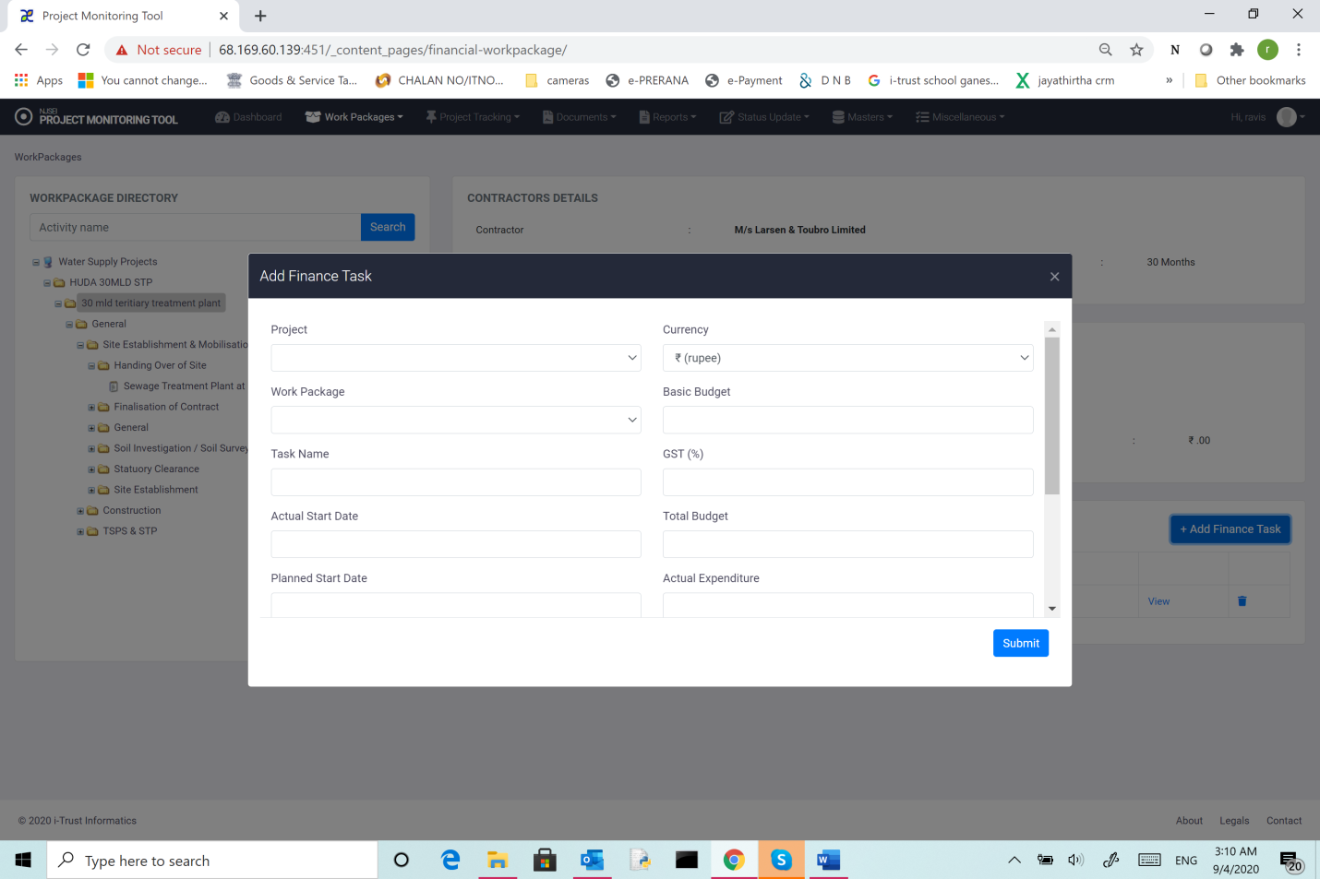

**Task name**: Name assigned to the task

**Discipline**: Choose from available list.

**Actual Start date**:

**Planned end date**: As per submitted plan.

**Projected start date**: (relevant if project has not started on planned date)

**Owner**: Choose from drop down list the user who has ownership rights on activity.

**Description**: Brief description of activity

**Currency**: Choose currency (INR/USD/YEN) for budget.

**Budget**: Budget (in chosen currency- INR/USD/YEN)

**GST** : in Percentage.

**Actual expenditure**: Actual expenditure incurred so far

**Actual end date**:

**Planned end date**: As per submitted plan.

**Projected end date**: (relevant if project has not ended on planned date)

**Status:**Current status of the activity.

**Click “Submit**”

Once saved, the task will be shown as a node in the tree view below the “work package”